**An analysis using Latent Growth Modelling**

Covariance of Latent Factors

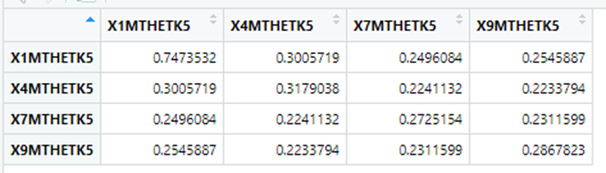

The table above shows the variance of the math ability of kindergarten students over time and the covariances show the relationship between factors over time. From the variance covariance matrix of the latent factors, there exist a positive correlation among the variables. That implies that they as a variable is affected, the other is also affected, hence the decrease in one lead to a decrease in the other factor.

Mean of Latent Factors

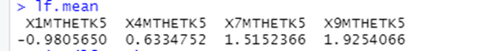

This table shows the average improvement of maths ability in kindergarten over time.

Summary statistics of Latent Factors

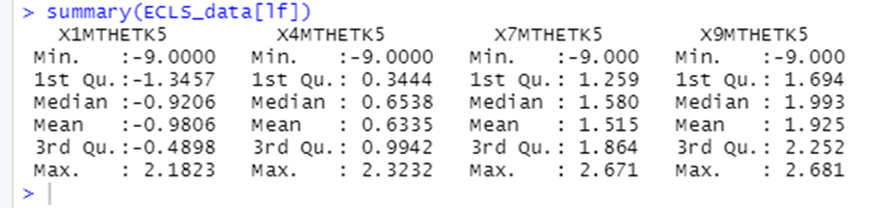

Hypothesis Question 1: Does math ability change over time by variables (gender, SES etc) from the beginning of kindergarten through the end of the fifth grade?

|  |  |  |  |
| --- | --- | --- | --- |
|  | Coefficient | | |
|  | b | SE | Z-Value |
| X1MTHETK5 |  |  |  |
| PIEXPECT | -.0148 | 0.007 | -22.266 |
| X12SESL | 0.387 | 0.013 | 29.051 |
| X_CHSEX_R | -0.328 | 0.019 | -17.081 |
| X2DISABL | -0.012 | 0.007 | -1.660 |
|  |  |  |  |
| X4MTHETK5 |  |  |  |
| PIEXPECT | 0.043 | 0.007 | 6.220 |
| X12SESL | 0.247 | 0.014 | 17.813 |
| X_CHSEX_R | 0.014 | 0.020 | 0.685 |
| X2DISABL | 0.029 | 0.007 | 3.928 |
|  |  |  |  |
| X7MTHETK5 |  |  |  |
| PIEXPECT | 0.153 | 0.007 | 20.731 |
| X12SESL | 0.190 | 0.015 | 12.250 |
| X_CHSEX_R | 0.184 | 0.022 | 8.382 |
| X2DISABL | 0.044 | 0.008 | 5.357 |
|  |  |  |  |
| X9MTHETK5 |  |  |  |
| PIEXPECT | 0.192 | 0.008 | 23.363 |
| X12SESL | 0.202 | 0.018 | 11.323 |
| X_CHSEX_R | 0.303 | 0.025 | 12.130 |
| X2DISABL | 0.052 | 0.009 | 5.463 |

Table 1 shows if math ability of kindergarten students change over time by sex and other variables from the beginning of kindergarten through to the end of the fifth grade. There was a negative slope(-0.328) and then in the second grade it became positive (0.014). Hence, there was a change over time by sex from the beginning of the kindergarten to the end of the fifth grade.

Also for other variables such as child with disability, SES score which represents parents salary, education and prestige score of Parents Jobs, How far in school parents expects Child to go, there was a positive change over the on the maths ability of kindergarten students.

Hence,there was a significant difference in the math ability of kindergarten students over time by sex, expectations, disability etc.

In the model below, a basic LGCM with a quadratic growth factor and eight measurement occasions of cortisol is depicted. The latent variables in this model are the intercept and slope (i.e., linear and quadratic) growth factors. For the growth factors to represent change over time, the paths between the cortisol measurement occasions and the growth factors are fixed to specific values.

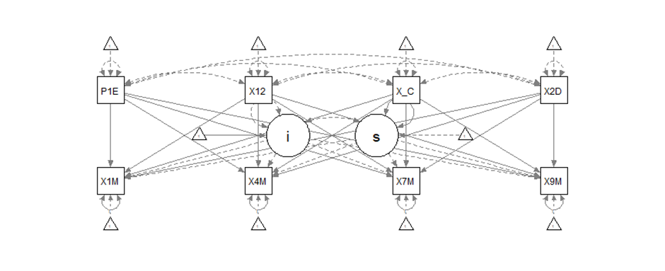

> AIC(ECLS.fit1)

[1] 22166.66

>

> fitMeasures(ECLS.fit1, c("cfi","rmsea","srmr"))

cfi rmsea srmr

0.000 0.524 0.344

Hypothesis Question 2:Do gender gaps in math achievement during elementary school remain in the 2010 children from single-parent families?

|  |  |  |  |
| --- | --- | --- | --- |
|  | Coefficient | | |
|  | b | SE | Z-Value |
| X1MTHETK5 |  |  |  |
| X_CHSEX_R | -0.730 | 0.016 | -44.964 |
| X4MTHETK5 |  |  |  |
| X_CHSEX_R | 0.238 | 0.016 | 14.456 |
| X7MTHETK5 |  |  |  |
| X_CHSEX_R | 0.766 | 0.017 | 44.584 |
| X9MTHETK5 |  |  |  |
| X_CHSEX_R | 1.015 | 0.018 | 55.537 |

Table 2 shows the gender-gaps in math achievement during elementary school remain in 2010 children from single parent families.

From the results from the table, it can be seen that there was a positive improvement in gender-gaps in math achievement during elementary school in 2010 from children with single parent.

In the model presented below, a basic LGCM with a quadratic growth factor and four measurement occasions of cortisol is depicted (X1M, X4M, X7M and X9M). The latent variables in this model are the intercept and slope (i.e., linear and quadratic) growth factors. For the growth factors to represent change over time, the paths between the cortisol measurement occasions and the growth factors are to be fixed to specific values.

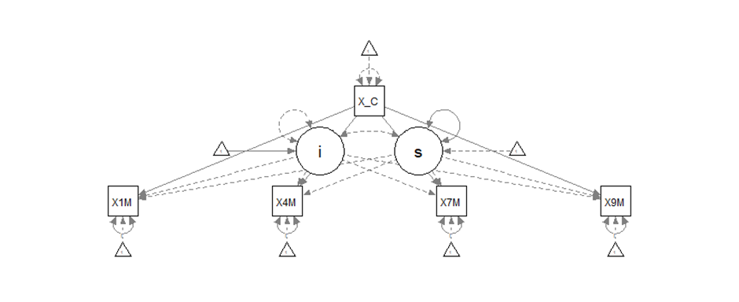

> AIC(ECLS.fit2)

[1] 25015.5

>

> fitMeasures(ECLS.fit2, c("cfi","rmsea","srmr"))

cfi rmsea srmr

0.0 0.590 0.948

Hypothesis Question 3: How does the parental involvement include parents' educational expectations for their children, beliefs in skills that children need to succeed in kindergarten and parents cognitive involvement in facilitating boys' and girls mathematics proficiency with a single parent?

|  |  |  |  |
| --- | --- | --- | --- |
|  | Coefficient | | |
|  | b | SE | Z-Value |
| X1MTHETK5 |  |  |  |
| X1HPARNT | -0.190 | 0.013 | -14.153 |
| P4HLPHWK | -0.145 | 0.010 | -14.692 |
| P7HWKCMP | -0.116 | 0.013 | -8.631 |
| T2PARIN | 0.040 | 0.011 | 3.643 |
| P1EXPECT | -0.033 | 0.008 | -4.353 |
|  |  |  |  |
| X4MTHETK5 |  |  |  |
| X1HPARNT | -0.095 | 0.014 | -6.840 |
| P4HLPHWK | -0.050 | 0.010 | -4.860 |
| P7HWKCMP | 0.052 | 0.014 | 3.749 |
| T2PARIN | 0.088 | 0.011 | 7.865 |
| P1EXPECT | 0.035 | 0.008 | 4.472 |
|  |  |  |  |
| X7MTHETK5 |  |  |  |
| X1HPARNT | -0.042 | 0.015 | -2.733 |
| P4HLPHWK | 0.002 | 0.011 | 0.192 |
| P7HWKCMP | 0.144 | 0.015 | 9.607 |
| T2PARIN | 0.103 | 0.012 | 8.396 |
| P1EXPECT | 0.077 | 0.009 | 9.047 |
|  |  |  |  |
| X9MTHETK5 |  |  |  |
| X1HPARNT | -0.040 | 0.017 | -2.303 |
| P4HLPHWK | 0.023 | 0.013 | 1.861 |
| P7HWKCMP | 0.187 | 0.017 | 11.214 |
| T2PARIN | 0.129 | 0.014 | 9.280 |
| P1EXPECT | 0.096 | 0.010 | 10.047 |
|  |  |  |  |

Table 3 shows how some variables (e.g. types of parents in household, how often do you help with your child’s homework? Frequency of parenting/family activities, Teacher rated parental) help in facilitating boys' and girls’ mathematics proficiency with a single parent?

The types of parents in the household had a negative impact in facilitating the children's mathematics proficiency with a single parent.

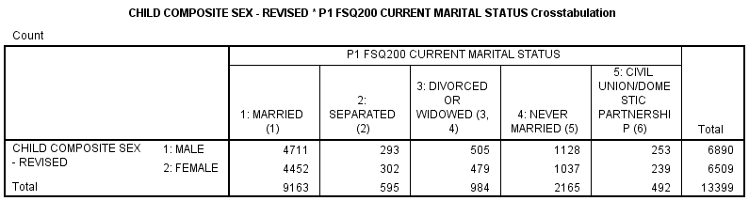

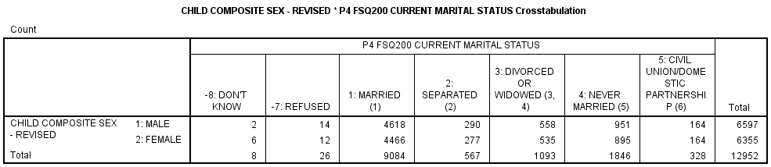

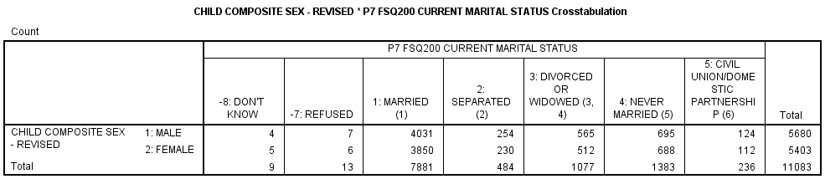

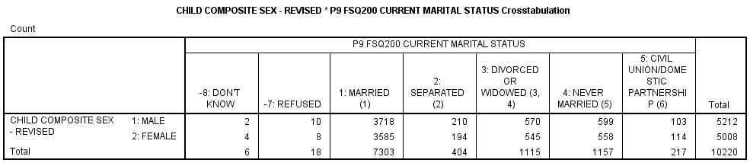

Here's the statistics of male and female children staying with both parents, single parents etc.

How often parents helped with their children's homework helped in facilitating the children's proficiency positively with a single parent. There was an improvement over time.

All other variables also had positive improvement in facilitating the children's proficiency in mathematics despite living with a single parent

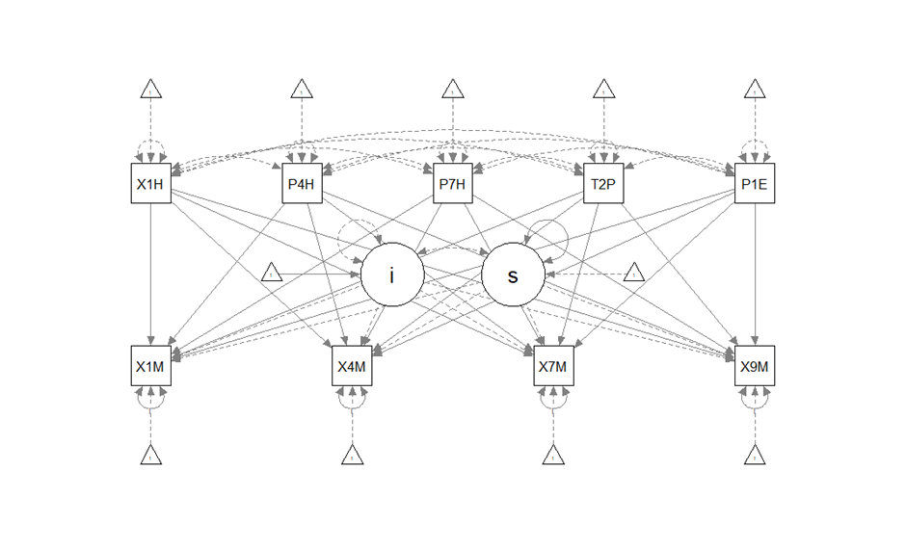

> AIC(ECLS.fit3)

[1] 22103.53

>

> fitMeasures(ECLS.fit3, c("cfi","rmsea","srmr"))

cfi rmsea srmr

0.000 0.513 0.257

Hypothesis Question 4:

How do executive functions include working memory and cognitive flexibility relate to the trajectories of gender gaps in math achievement?

|  |  |  |  |
| --- | --- | --- | --- |
|  | Coefficient | | |
|  | b | SE | Z-Value |
| X1MTHETK5 |  |  |  |
| X7PWKMEM | -0.071 | 0.007 | -10.652 |
| X7TWKMEM | -0.492 | 0.011 | -45.168 |
|  |  |  |  |
| X4MTHETK5 |  |  |  |
| X7PWKMEM | 0.096 | 0.008 | 12.425 |
| X7TWKMEM | 0.191 | 0.012 | 15.936 |
|  |  |  |  |
| X7MTHETK5 |  |  |  |
| X7PWKMEM | 0.184 | 0.010 | 17.929 |
| X7TWKMEM | 0.568 | 0.015 | 38.433 |
|  |  |  |  |
| X9MTHETK5 |  |  |  |
| X7PWKMEM | 0.236 | 0.013 | 17.507 |
| X7TWKMEM | 0.733 | 0.019 | 39.597 |
|  |  |  |  |

From the results from the table above, it can be seen that the parent's report working Memory and that of the teacher's working memoryLimitation: There was no data captured in the time points for cognitive variables. The working memory had only one time points which was analysed.

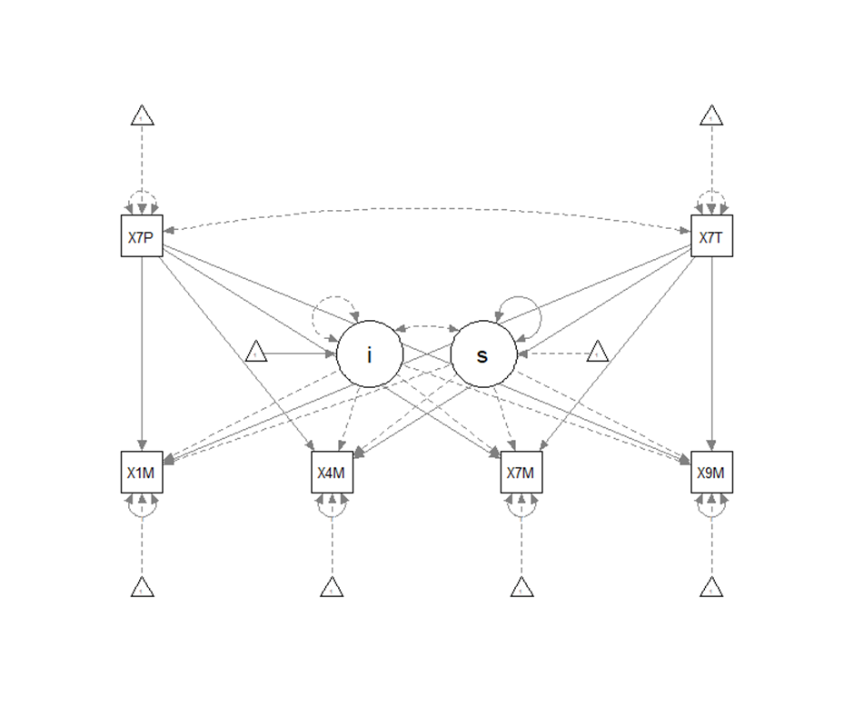

> AIC(ECLS.fit4)

[1] 26972

>

> fitMeasures(ECLS.fit4, c("cfi","rmsea","srmr"))

cfi rmsea srmr

0.000 0.643 1.798

>